Unit 1: Introduction to Wind Energy

# 1. Introduction

## Learning outcomes

The purpose of this learning unit is to provide an overview of the wind resource as well as of modern wind turbines. This unit focuses on variable speed, three blade wind turbines for large scale applications in the MW range.

At the end of this unit the student shall:

* Have gained an overview of the wind energy utilisation and the modern wind turbine
* Understand the concept of power coefficient and its optimisation for different applications
* Understand the difference between mesoscale wind modelling and micro-siting
* Be familiar with the Weibull distribution and its parameters
* Be familiar with the IEC wind site classification

# 2. Input

# History, background and overview of the modern wind turbine

Humanity has utilised the power of the wind to propel boats since thousands of years. The earliest record of a sailing ship was an Egyptian vase from ca. 3500 BC. Ever since, sailing ships have been widely used and sailing boats remain a popular choice for navigation even today. Sometime after 500 AD the Persians expanded on wind energy utilisation and began utilising the energy of the wind to power grain mills and for pumping water. Wind mills like the ones found in the Netherlands, date from mid 1400 AC and are considered the origin of modern wind turbines.

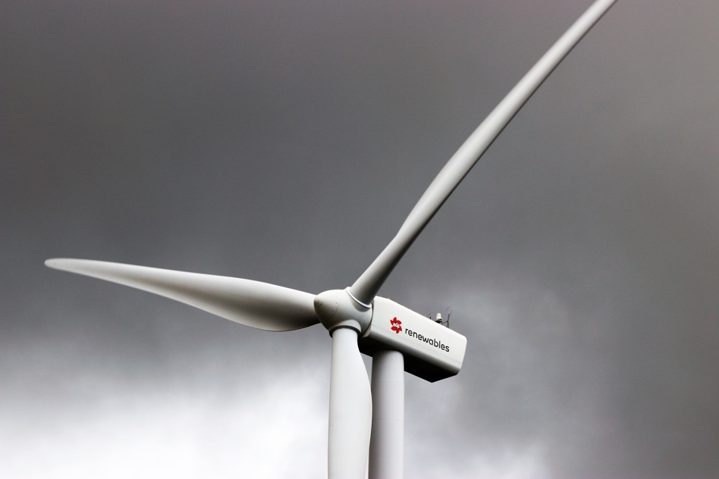

Figure 1. Horizontal axis wind turbine. Photo by Expect Best from <https://www.pexels.com/photo/white-3-blade-windmill-under-cloudy-sky-744344/>

Throughout history wind powered systems have evolved and improved, and wind turbines in particular have been grouped in two main categories: horizontal axis and vertical axis. Large scale units are primarily horizontal axis wind turbines and constitute most of the current wind energy installations. One of the main reasons why horizontal axis wind turbines dominate the market is because they are capable of extracting more power out of a given amount of wind resource. However vertical axis configurations can be advantageous when integrated into buildings and used for small scale applications. This course focuses on large scale horizontal wind turbines that are grid connected.

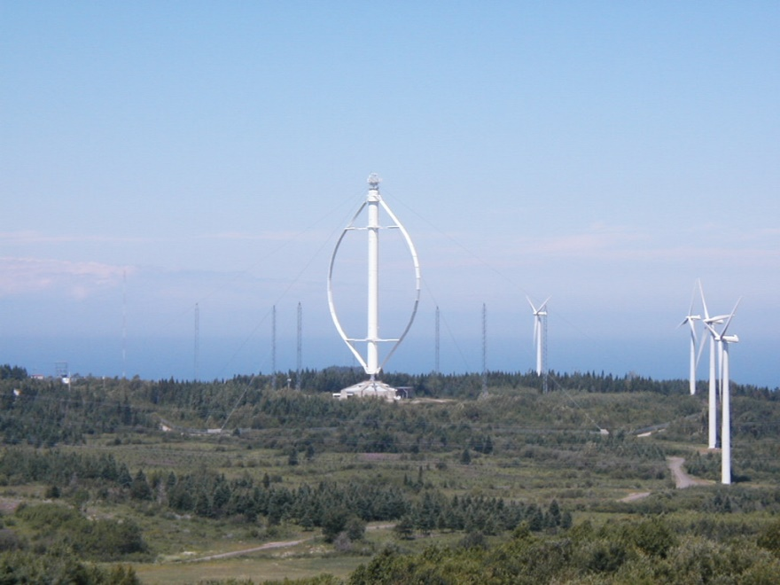

Figure 2. Horizontal axis wind turbine. Photo by Guillom from <https://commons.wikimedia.org/wiki/File:Eoliennes_Gaspesie.jpg>

# History, background and overview of the modern wind turbine

The first automatically operated wind turbine is believed to have been built in Ohio, U.S.A., in the late 1800s. This structure had a 17m rotor diameter constituted by 144 wooden blades. It was a slow rotating machine that powered a 12 kW generator.

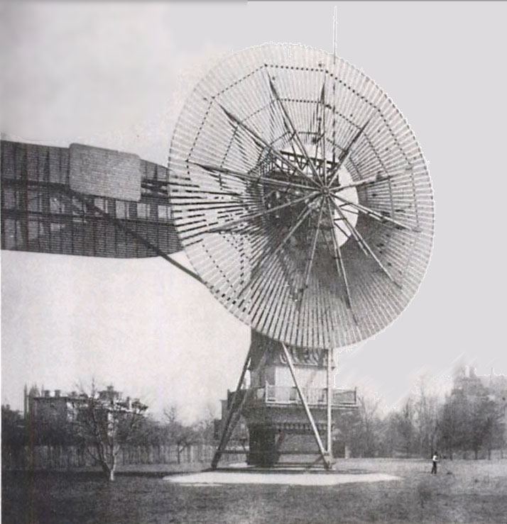

Figure 3. Wind turbine built by Charles Brush. Photo from <https://commons.wikimedia.org/wiki/File:Wind_turbine_1888_Charles_Brush.jpg>

Although this first wind turbine built by Charles Brush differs from the usual wind mills found in the Netherlands, both structures have one thing in common: a higher rotor solidity when compared to the modern three blade wind turbine like the one in Figure 1.



Figure 4. Classic wind mill. Photo by Pixabay from <https://www.pexels.com/photo/architecture-blade-building-church-161123/>

Rotor solidity is the ratio of the area covered by the blades to the swept area of the rotor. This means that a wind turbine with a higher number of blades, like the one built by Charles Brush, will have a higher rotor solidity than a modern wind turbine like the one in Figure 1. Similarly, a classic wind mill with wider blades like the one in Figure 4, will also have a higher rotor solidity than the wind turbine from Figure 1. Rotors with high solidity have been used traditionally for low-speed applications, like for example grinding. This means that for such applications a higher power coefficient is desired at lower rotor speeds.

The power coefficient Cp is a measure of wind turbine efficiency and it is defined as the ratio between the output of the wind turbine *Pout*, divided by the power available in the wind *Pwind* flowing through the rotor section.

with

where

❒ is the air density

*A* is the rotor swept area

*v* is the wind speed at hub height

and where *Pout* is the output of the turbine

The *Cp* reflects what fraction of the energy available in the wind is actually being extracted and delivered by the wind turbine. The amount of energy extracted will depend on the aerodynamic performance of the rotor, while the amount of electricity delivered by the turbine will additionally be influenced by the mechanical losses in the transmission of the power from the rotor to the electrical system of the wind turbine, as well as by the efficiency of the electrical components such as the generator and power electronics.

Since the energy extracted from the wind is determined by the aerodynamics of the rotor, the blade profile is typically designed for an optimised Cp within a given wind speed range. Three blade turbines are designed for an optimised Cp somewhere in the range between 5m/s and 11m/s, what for modern wind turbines corresponds to a tip speed ratio in the range of 5 to 8.

The tip speed ratio, 𝛌 or TSR, is the ratio between the blade tip linear velocity and the wind speed at the wind turbine’s hub height. It can be calculated as:

Where 𝜔 is therefore angular velocity

*R* is the rotor radius

*v* is the wind speed at hub height

Figure 5. Power coefficient to tip speed ratio for different applications. Figure from <http://resolver.tudelft.nl/uuid:60a3ca0e-25f0-4892-ae52-300dcb4443ab>

As it can be seen from Figure 5, wind turbines and wind mills with high rotor solidity have a most efficient operation for lower values of 𝛌. Modern wind turbines on the other hand have an optimised operation for increasing 𝛌 values, as solidity is correspondingly reduced for three blade, two blade and single blade units. The reason why most modern wind turbines have settled at three blades has various influencing factors, but one driving element is the management of mechanical loads. Two blade turbines are more prone to wobbling due to gyroscopic effects, causing stability issues for the structure. Another important aspect is the aerodynamic noise produced by the blades, often referred to as “whooshing”. Two blade units have a higher rotational speed and this results in a louder operation.

A typical three blade wind turbine consists of four main subsystems:

* The rotor, which we have already introduced and is composed of the blades, hub and pitch system,
* The machine head, which contains the power transmission and the generator,
* The tower, and
* The power electronics, often referred to as down tower assembly, since it is usually located at the entrance of the tower.

In terms of software, wind turbines have a controls system, which governs the rotor speed for variable speed turbines and the safety chain for fault management. If connected to the grid within a wind farm, there are often two additional systems:

* The grid connection management system, which regulates power quality, usually at the wind farm level and often required for grid code compliance,
* The supervisory and data acquisition system, also known as the SCADA system, which allows monitoring of all wind turbines in the wind farm simultaneously and which registers historic data for analytics and fault investigation.

# The wind resource

The energy contained in the wind originates from the sun, which heats up the air in the atmosphere unevenly. This creates differences in atmospheric pressure and thus, air moves from higher to lower pressure areas generating wind. Atmospheric phenomena with spatial scales ranging from few to several hundred kilometres is referred to as mesoscale meteorology. Mesoscale wind models have grid spaces ranging from 1km to 10km and are used for generating high level wind maps. These high-level maps are useful for identifying regions with good wind resource potential. The Global Wind Atlas is a popular mesoscale application which is accessible for free online.

The Global Wind Atlas as explained in the official website <https://globalwindatlas.info>, “is a free, web-based application developed to help policymakers, planners, and investors identify high-wind areas for wind power generation virtually anywhere in the world, and then perform preliminary calculations.” In this website there are further explanations on the methodology used for creating the wind maps as well as on the origin and quality of the datasets.

Figure 6. Example of a wind map for the region around Afghanistan. Image from <https://globalwindatlas.info>

Figure 6 shows an example of a wind map available from the Global Wind Atlas application. It can be observed that on the western side of Afghanistan towards the border with Iran, there is a dark red area which indicates a high wind regime. On the other hand, in the northeaster side towards Tajikistan, the map turns mostly blue indicating a low wind area, likely unattractive for wind energy installations.

Once a specific site has been identified for installing wind turbines, the project developer will require more accurate wind data than what mesoscale models can offer. Therefore, it is necessary to install wind measurement equipment at site, which will record wind speed data for several months. At least one met mast containing several anemometers and wind vanes at different heights will be installed. For large projects, developers will usually install various met masts. The met mast layout requires planning to ensure that the data can be used later for validating the micro-siting model.

Micro-siting is the process for determining the specific location of each wind turbine, and is usually done using industry-standard software. These software are capable of modelling the wind flow according to site specific conditions, with the ultimate goal of estimating and maximising the annual energy production of the wind farm.

The data-logger in the met mast records the windspeed every second, as well as the wind direction measured by the wind vane. The most commonly used equipment for measuring wind speed is the cup anemometer.

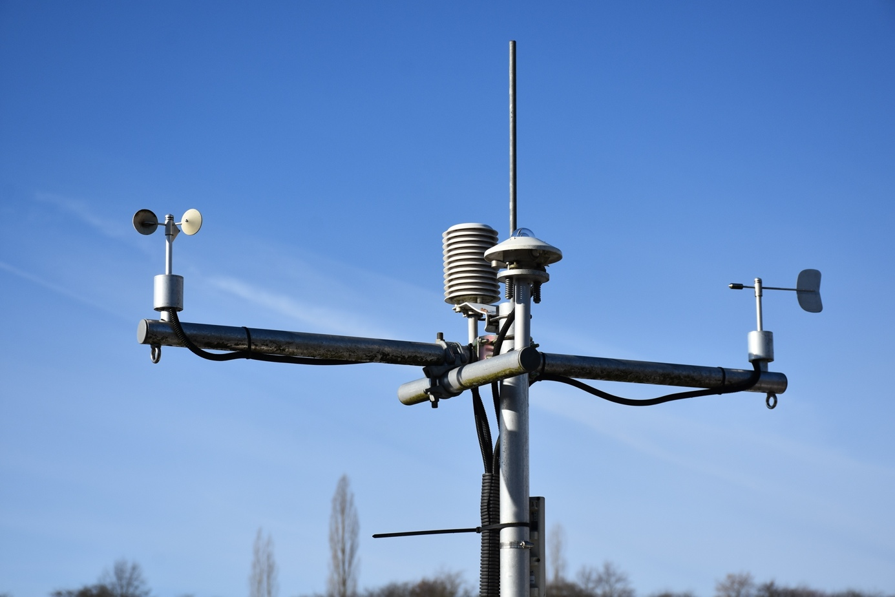Figure 7. Cup anemometer and wind vane. Photo by RitaE from <https://pixabay.com/photos/anemometer-weather-station-3977718>

Cup anemometers are required to be calibrated and properly maintained to ensure that the readings are accurate. In areas where temperatures can drop below freezing point for prolonged periods, heated anemometers are recommended to avoid icing from interfering with the measurement campaign. If a met mast is intended to be used for validating a wind turbine power curve, it is usually required that it is built and located in accordance to the relevant standards. Once the measurement equipment has been installed and the data set collected is sufficient, a site-specific Weibull distribution can be generated.

# The Weibull distribution

The wind speed distribution follows a Weibull curve, which is a continuous probability distribution. The Weibull distribution can be described by the shape parameter and the average wind speed , such that:

where

is the wind speed

is the shape factor

is the scale parameter

and where

with 𝚪 being the gamma function

One important characteristic of the Weibull distribution is that it does not admit negative values. Also, unlike the normal distribution, for a Weibull distribution the average and the mode do not coincide, this means that the average is not the value that appears the most often in the data set. The average wind speed of a site indicates therefore that for most of the time the wind will be blowing with a lower wind speed.

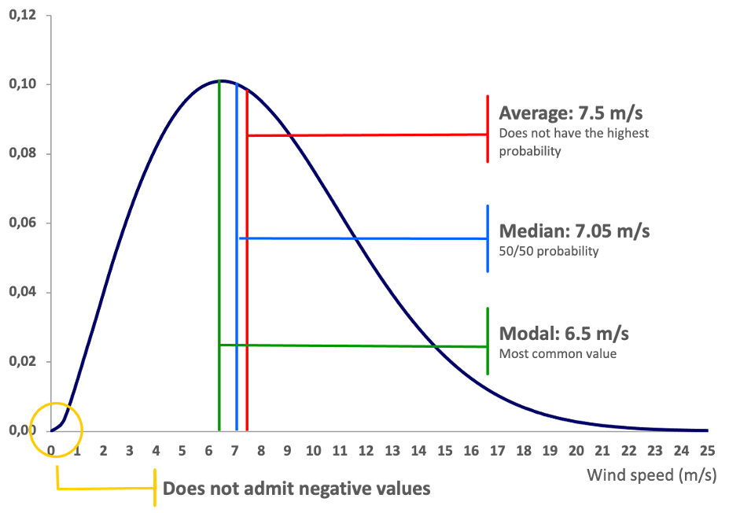Figure 8. Example of a Weibull distribution average wind speed of 7.5 m/s and a shape factor k of 2.

The shape factor *k* relates to the breadth of the curve, so that the probability of finding wind speeds in lower and higher ranges is higher for a site with a *k* factor for example, of 1 or 1.5. Sites with a *k* factor close to 2.5 or 3 will seldom experience wind speeds exceeding 20 m/s.

The Weibull distribution describes the wind regime of the site but it does not provide any information regarding the wind direction. Each site is of course unique, but in general there are a few predominant wind directions. The wind rose of the site shows which ones are these predominant wind directions. The wind rose from Figure 9 for example corresponds to a site where the predominant wind direction is south west.

Figure 9. Example of a wind rose.

For a given site the wind rose is key information, since the wind turbines within a wind farm must be installed in such a way that they interfere as little as possible with each other’s access to the wind resource. This means that ideally, all wind turbines face the predominant wind direction without any obstacles in front of them, so that they stand in the wind free flow. In practice this is usually not the case, especially in regions where land availability is limited. Therefore, micro-siting software is required for optimising the wind farm layout. For this purpose, industry standard micro-siting software model a dedicated Weibull distribution with its corresponding wind rose for each individual wind turbine position.

Wind resource modelling is influenced by several parameters, the most common ones are:

* The terrain complexity: depending on the flatness of the terrain, it can be more or less complex. Flat areas are usually easy to model and do not carry too much uncertainty. On the other hand, abrupt terrains, ridges and forests, to name some examples, introduce complexity, are difficult to model and carry higher levels of uncertainty.
* The roughness of the surface: depends on the vegetation, the number of obstacles in the surrounding areas such as buildings, tall trees and so on.
* The distance between wind turbines: the wind behind a wind turbine is turbulent and cannot be exploited by a neighbouring turbine. This is what is known as the wake effect. Therefore, wind turbines must be installed maintaining a minimum distance between each other, the closer they are to each other the more the wake effect will impact the energy production.

# The IEC standard and the wind class categorisation

The International Electrotechnical Commission (IEC) is an international organisation that prepares and publishes international standards for all electrical, electronic and related technologies. The IEC has a set of standards related to wind energy that are used by most of the large wind turbine manufacturers. The IEC standards are relevant for the design of equipment, but there are also several documents dedicated to the measurement of wind turbines performance, such as output and noise emissions.

The main list of the relevant IEC standards for the design and operation of wind turbines is the following:

* IEC 61400-1 Design requirements
* IEC 61400-12 Power performance measurement
* IEC 61400-13 Noise measurement
* IEC 61400-21 Measurement and assessment of power quality characteristics of grid connected wind turbines
* IEC 61400-24 Lightning protection

The IEC standard also defines a standard classification of wind classes, that is used for the design of wind turbines. For designing a wind turbine, it is necessary to model the expected mechanical loads acting on it based on reference wind conditions. This is the purpose of the IEC wind classes, they provide a baseline for reference site conditions for three main wind speeds. There are three different IEC wind classes: class I, class II and class III, with the first one being the one with the highest wind resource and the third one corresponding to weaker wind resource. The table below shows the three wind classes with their corresponding reference wind parameters.

|  |  |  |  |
| --- | --- | --- | --- |
|  | **IEC Wind Class** | | |
| Class I | Class II | Class III |
| **Annual Average Wind Speed** | 10 m/s | 8.5 m/s | 7.5 m/s |
| **Reference Wind Speed (*Vref*)** | 50 m/s | 42.5 m/s | 37.5 m/s |
| **50-year Return Gust** | 70 m/s | 59.5 m/s | 52.5 m/s |
| **1-year Return Gust** | 52.5 m/s | 44.6 m/s | 39.4 m/s |

Table 1.The IEC wind class categorisation.

The IEC reference sites all use a shape factor *k* of 2, which is a particular case of the Weibull distribution known as a Rayleigh distribution. The Reference Wind Speed *Vref* is a value for the recurrent 50-year gust which lasts at least 10 min, while the 50- and 1-year Return Gusts last only 3 seconds.

There is an additional IEC classification for turbulence intensity. The turbulence intensity is defined as the standard deviation of the wind speed divided by the average wind speed, usually within a 10-minute bin. The data logger in the met mast registers one reading of the wind speed per second. These readings are then binned in 10 min intervals, what yields a wind speed average and a corresponding standard deviation 𝝈 for each bin.

The turbulence intensity is then:

where

is the average wind speed

𝝈 is the standard deviation

The turbulence intensity therefore decreases with increasing average wind speeds.

The IEC classification for turbulence intensity I*ref* is as follows:

|  |  |  |  |
| --- | --- | --- | --- |
|  | **A** | **B** | **C** |
| **I*ref*** | 0.16 | 0.14 | 0.12 |

Table 2.The IEC turbulence intensity categorisation.

Wind turbine models are normally certified to one of the IEC wind class reference sites. A given wind turbine model will be, for example, certified to wind class IEC IIIA, meaning that this model has been designed to withstand a 20-year operation under mechanical loads corresponding to a wind regime class III as per Table 1, and a turbulence intensity of 16% as per Table 2. When a project developer evaluates this turbine model for a specific site, it will be necessary to run a mechanical loads assessment that will simulate the 20-year operation under the site-specific wind conditions, which are the result of the wind modelling based on the readings from the measurement campaign. This site-specific loads assessment is conducted by the wind turbine manufacturer as part of the request for proposal process.

Often manufacturers certify a wind turbine model to a wind class IEC S. In such cases, the manufacturer has modified one or more of the wind parameters from Table 1. For example, the annual average wind speed used for the design is 7m/s instead of 7.5m/s. In this case the certification will be to a wind class S based on the IEC wind class III. The details of these deviations are captured in the wind turbine’s certification documentation.

# 3. Summary

Wind energy has been utilized by mankind since thousands of years and continues to be a source of energy in today’s society. Modern wind turbines are mostly horizontal axis units with a three blade rotor, optimized for energy generation at large scale.

The power coefficient *Cp* is an indication of how efficiently a wind turbine extracts energy from the wind resource. Wind powered turbines and mills operate at those ranges of the tip speed ratio for which the *Cp* is highest, depending on the application.

High level wind maps help investors and developers screen regions for identifying those areas with good wind resource potential. Once a specific site has been selected, a local measurement campaign is required for estimating the site-specific wind resource.

The site-specific Weibull distribution describes the wind regime, based on the average wind speed and the shape factor. In order to have the full information necessary for estimating the wind resource at a specific site, a wind rose is generated using the wind data measured. The wind rose indicates which are the primary wind directions for optimising the wind farm layout.

The IEC site classification offers a standardization of the wind regime for the reference wind sites used for wind turbine design. There are three wind classes for different annual average wind speeds, each one with given values for describing recurring extreme wind gusts. Additionally, the IEC defines three classifications for the turbulence intensity. Together with the wind class, a reference wind site is accompanied by one of the turbulence intensity reference values.

# 4. Self-Test Set

# Single Choice Set

**What is the Power Coefficient Cp?**

A measure of the wind turbine efficiency

A parameter used to describe the Weibull distribution

The ratio between the tip speed ration and the average wind speed

**What is the purpose of the measurement campaign?**

To obtain data for estimating the site-specific wind resource

To generate a high-level wind map

**What are the three IEC wind classes for reference wind speeds?**

Class I, II and III

Class A, B and C

Class blue, red and green

**What is the turbulence intensity?**

The ratio between the average wind speed and the standard deviation

An indication of the average wind speed

The ratio between the tip speed ratio and the average wind speed

|  |  |
| --- | --- |
| **Percentage Correct** | **Feedback** |
| <25% | Not there yet. Please study this learning unit again to understand the basics of wind energy. |
| 25% - 74% | You have a first grasp of the topic but there is still a lot missing. Consider revisiting the concepts associated with the wind resource. |
| 75% - 99% | Good job, nearly there! There are still a few missing links but you are on a good path. |
| 100% | Perfect score! Congratulations! |