Author Guidelines

13.05.2020

Content
Background 3
Context 3
Technical requirements 3
Didactical approach 4
The concept 4
The learning material 5
Course structure 6
Basic structure 6
Unit structure 7
Orientation 7
Input 7
Examples and exercises 8
Submissions 8
Further information 8
Didactic Elements 9
Quiz 9
True-False 9
Single Choice 9
Multiple Choice 9
Fill in the word 9
Open Questions 10
Sorting Tasks 10
Sort words to text 10
Sort text to elements 10
Hotspots 11
Dialog Cards 11
Audio 12
Audio Recording 12
Videos 12

Author
Sustainum – Institut für zukunftsfähiges Wirtschaften Berlin

Background
The Institute of Distance Learning at Beuth University of Applied Sciences in Berlin, Germany is currently coordinating a project (EDUTEX) for development cooperation in the textile sector in Ethiopia. The aim of the project is to expand economic relations and cooperation between universities and industry between Germany and Ethiopia in the textile sector. By increasing the practical relevance of existing courses of study in Ethiopia, more graduates should be able to find a job locally. For this purpose, online learning material is to be created for various courses.
In order to understand the general structure of the courses and their learning units, it is helpful to get to know the context and didactical approach of the EDUTEX project.

Context
Students in Ethiopia heavily rely on the university’s infrastructure in conducting their studies. A large portion of users in the country access the internet only through mobile devices and the Ethiopian government is in the habit of shutting down internet access or restrict it at times. On average the connectivity speed in Ethiopia was measured at 5 kB/s and internet access was only available at 80% of the time. To put these figures in context, imagine that downloading a single image file would take you about 1 ½ minutes.
Moreover, due to the global Covid-19 crisis, Ethiopia has declared a state of emergency and several regions are in and out of lock-down depending on the virus load. Since conditions are not expected to improve until the widespread availability of a vaccine, it has to be assumed that students will have to work on their own and in a virtual learning context most of the time.

Technical requirements
The theme of the learning units can be described as “Mobile – Offline – Asynchronous”. All content and didactical elements are optimized for the distribution in a setting in which internet access is scarce and the primary digital device is a smartphone. In order to account for these conditions, the EDUTEX project has decided to follow these guidelines in creating learning material:
- At least 80% of the learning material must be fully accessible offline
- Learning material must be optimized for mobile devices
- Student interactions and feedback loops for exercises and submissions must be designed to be asynchronous
- Self-directed and autonomous learning is assumed to be the default
- Modular content which consists of self-contained learning units

Didactical approach

The concept
The courses and the learning units to be developed in the EDUTEX project will take place in an interactive and student-centred learning setting, following the “principle of complete action”. Here learning takes place in cycles, moving from information, planning and decisions to implementation, review and reflection (see figure 1).
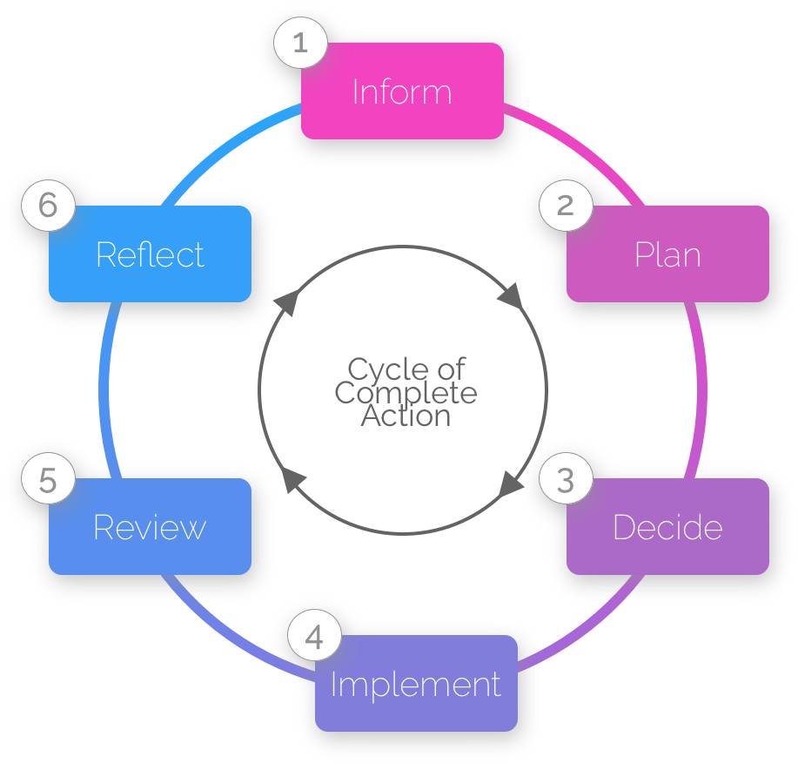
Figure 1. The Cycle of Complete Action
Basically, the students acquire the competences aimed at by the course by working on a wider assignment, where the course content is needed for. This assignment might be a practical problem the students encounter or, if this is not possible, a case study presented by their teacher. It will be divided in several (sub-) tasks, related to the single learning units.
The complete-action approach starts with the first task that has to be solved. For this purpose didactically prepared learning material must be formulated. Every task has a goal that is clearly defined by the assignment. Due to its work-relevance the learners can understand the meaning of the task and know what they are asked to do. The distinct steps must be processed in the correct order to ensure the desired result:
1. Inform - What is the goal and which equipment and/or additional information do I need?
2. Plan - How can I proceed? Independent creation of own complete work plan for the task.
3. Decide - What do I have to do, which implementation approach do I choose?
4. Implement - Carrying out the assignment
5. Review - Has the assignment been carried out completely, and in an expert, customer-friendly and appropriate manner?
6. Reflect - What has to be further improved, also regarding the next assignment? Do I need additional and supplementary knowledge and more generalization about the subject content?
From preparation through to review, participants independently carry out their tasks, as a team or – if this should not be possible – individually. The trainer supports the learners but tasks are to be carried out independently. The interplay between independent work and phases of strong and weak support ensures that the participant increasingly develops the ability to solve problems independently.
Two guiding principles make the complete-action cycle successful:
- Flexibility: Assignments always offer some space for decision to the students, thus there are several options to choose from. The principle of action-oriented learning implies that there are several viable ways to achieve the goal of the assignment. This leeway allows the learner to get involved personally.
- Quality: If the result is deficient it soon becomes evident which process step had deficiencies due to the clear structure of the complete action. The pursue of these deficiencies allows for a deeper exploration of difficulties in the learning process.

The learning material
Within this concept, the learning material has a decisive role. It should prepare the student not only to understand the content, but also support him in successfully handling the tasks he has to work on. Therefore, each learning unit should
- start with an orientation,
- cater to different learning preferences by using a range of didactical elements,
- give examples on how the content can be applied, and
- end with a transfer task in which the student has to apply the content.

Figure 2 summarizes the basic elements. Details will be described in the following chapters.
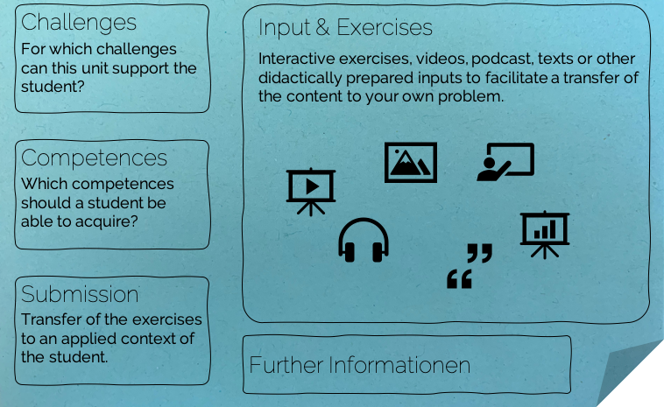
Figure 2. Basic elements in a unit

Course structure
Each course is modular in structure. It consists of learning units, each of which takes about 60 to 90 minutes to complete. This includes
- understanding the subject and its benefits
- read and understand the input, including any videos and presentations that may be included
- working through any of the didactic elements, e.g. a quiz or an exercise
- editing and uploading a submission task
Each course unit should stand on its own, i.e. it should be possible to work through it without having worked through the previous course units. However, technical terms, for example, do not have to be explained again and again. Instead, there can also be a cross-reference to the corresponding course unit.
Course units will be made available in two formats:
- Digital: To be viewed on a mobile device offline or online
- Analogue: To be viewed as a printout or as a pdf on a mobile device
The offline digital version is assumed to be the default and can consist of any of the didactical elements outlined in the “Unit Template”. The analogue version of the unit will only consist of text and images. Thus, central exercises and submission task should be designed to allow a pen-and-paper format. It must be possible to submit edited tasks / results without sending large amounts of data.

Basic structure
- Topical introduction to the course:
  - Background
  - Competence objectives
  - Scope
  - Literature and links
  - Contact person
- Summary of learning units in the course
- Numbering of the subject areas and learning units.
- Usage instructions (cross-course)
  - Software and platform
  - Interaction and submission process

For example, for a course in project management, the structure could look like this:
- Introduction to project management
- Summary of the learning units
- Content
  - PM_1.1: Planning – Project definition
  - PM_1.2: Planning – Goal definition
  - PM_1.3: Planning – Stakeholder analysis
  - …
  - PM_2.1: Implementation – Project meetings
  - PM_2.2: Implementation – Kick-Off
  - …
  - PM_3.1: Controlling – Resource tracking
  - …
- Usage instructions

Unit structure

Orientation
At the beginning of each learning unit there are always
- a description of the context in which the learning unit is located, and the questions that can be answered or solved with it. The lead question would be “What can this unit help you with?” Usually two or three challenges would be formulated like "A need to coordinate the capacity planning of a project".
- Two or three of the intended results, if possible formulated as competence objectives: “After working through this unit,…” e.g. the student should be able to explain the method to others”

Input
The content of the learning unit should be mostly text and illustrations such as graphics, pictures, tables (at least one per page). Additionally, further didactic elements (at least one every 2-3 pages) should be added to each course unit (e.g. quizzes, podcasts, sorting tasks). Examples of possible elements can be found here:
https://study.pile-system.com/lc-det/didact
These elements are intended to invite you to deal with the topic. The processing of these elements can be part of the results which the students have to hand in at the end of the work. If, for example, a quiz is included, the answers should also be submitted, and in the case of a podcast, perhaps the content could be summarized, etc.
Videos or presentations that can be streamed or downloaded from the Internet and that illustrate or supplement facts are also welcome but should not be central to the learning unit.

Examples and exercises
For each learning unit, the contents should be explained and made comprehensible by means of examples and exercises. These examples should preferably be part of one bigger example within a subject area, better still within the whole course. For instance, a wedding as an example for a course on project management followed up with the question of what tasks and methods to apply during the wedding preparation in the units on planning.

Submissions
For the submission task to a learning unit, students should transfer the learning content to a specific example of their own context or a given example sufficiently different to the examples given to illustrate the content. In case of the illustrative example of a wedding, the application for project management could be the planning of a large excursion. Thus, the students would have to apply the methods and steps to a different field.
The submission task should also include acceptance criteria, letting the student know what is expected from a satisfactory solution and what from a good one and thus provide the learner with constructive feedback.
At the end of each course unit, the examples worked through (and the results of additional tasks) must be handed in. For this purpose, the results should have a form and scope that allows them to be handed in easily even with a poor Internet connection. If necessary, it should be possible to solve the tasks with pen and paper and then to take a picture of the result with a mobile phone and send it in.

Further information
At the end of each learning unit there should be some literature references, further links or similar. In this way students can easily see where they can deepen the knowledge they have acquired.
Examples for learning units in this format can be found here:
https://study.pile-system.com/lc-ov
You should use the document “Unit Template” to create your own unit structure.

Didactic Elements
Note: Please see https://study.pile-system.com/lc-det/didact for the digital representation of the didactic elements.

Quiz
Single-Choice, Multiple-Choice, True-False... You name it.

True-False
HTML is a markup language | Yes
Another statement | No

Single Choice
What's a hyperlink?
A very fast connection between two objects
*A reference to data that the user can follow

What number is PI?
*3.14
9.82
5.12

Multiple Choice
Which of these are markup languages?
*HTML
*Markdown
Javascript
Css

Fill in the word
*Hypertext* is text with hyperlinks.
Every word with an *asterisk* will have to be *filled* by a student

Open Questions
A set of open questions, the student can fill out, download and send as a text afterwards.
- Please describe what hyperlinks can be used for?
- What is HTML used for in webdesign?

Sorting Tasks
You can use sorting tasks with words and images. You can even define hotspots on an image to indicate where an area of interest is which a student should drag an image or word onto.

Sort words to text
Task description:
Drag the words into the correct boxes
Items:
The inventor of the hyperlink was *Tim Berners Lee*
Microsoft was founded by *Bill Gates*

Sort text to elements
HTML Elements | Markup Languages
Hyperlinks  Headings | Markdown  Latex

Hotspots


Feedback correct: Yes, Tim Berners Lee invented the world wide web.
Feedback incorrect: nope

Note: Please also provide the image file separately as a .jpg or .png. Images should be at least 1024px wide at 72 ppi

Dialog Cards
Self test format with some dialog cards. Students can test and train their understanding of the content.

Front | HTML is a …
Back | markup language
Optional: If you want you can provide an image to go with the card

Front | Hyperlinks are used to …
Back | Reference to data

Audio
Audio Snippets or full podcasts
Please provide the audio file (as .mp3 or .wav) or the link to the website the audio file/podcast is on (as specific as possible)

Audio Recording
Students can record their answers in an audio message and download the audio file.
Task description:
Explain what a markup language is in 1 minute

Videos
Own videos, slides with audio and video or embedded youtube content.

Please provide the video file (best as .mp4) or the link to the website the video file is on (as specific as possible)

see https://en.wikipedia.org/wiki/Internet_in_Ethiopia

